Delivery Document

# Code Validation

I have used the w3c online check tool based on CSS3 to exam my all CSS file. It seems no syntax error already. But, if the check tool is based on CSS2.1, the system will arouse many errors because CSS3 adds so many new features.

The result come from HTML Thor has a little bit problem, like the following screenshots:

It told me that my HTML files all have the same syntax error. However, even the website itself also uses this way to add a small icon to the browser tab. Thus, it could be a bug of this app.

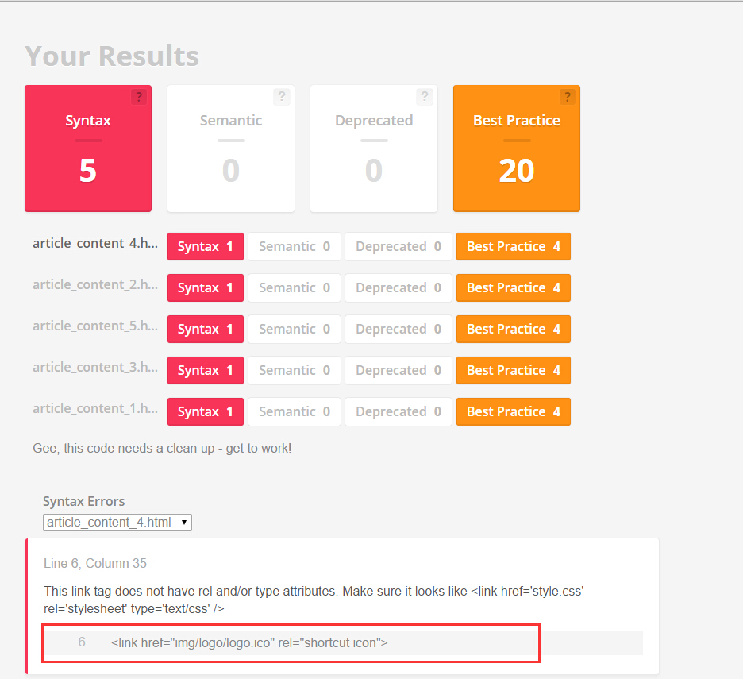

The other problem aroused by HTML Thor is about <select> tag. In new W3C HTML5 document, the selected attribute is not defined as a Boolean, but “selected” or empty string (<http://www.w3.org/TR/html-markup/option.html> ). Therefore, it is a mistake of HTML Thor.

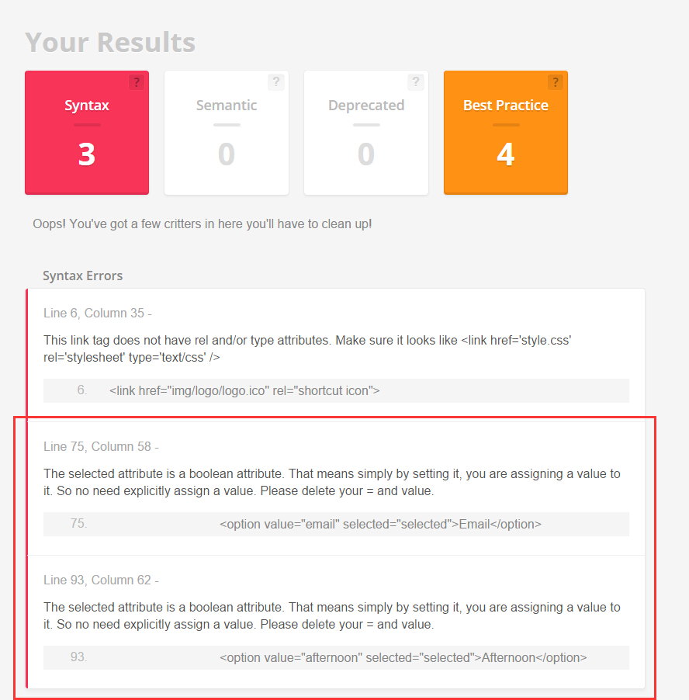

# JavaScript Implement

In this delivery, we code 4 small JavaScript programs for this website and put them in suitable places.

They are:

1. **Hero Slides** for the Index page.
2. Three **Form Validation** for “Join Us” page, Footer, and Register pop-up form.
3. **Pop-up form** for register form in “project-detail” pages.
4. **Back-to-Top** function in article content pages

You can find these programs at following files:

* **Hero Slides** is put in hero-slides.js;
* Three **Form Validations** are separately installed in two independent files: validation_joinus.js, validation_footer.js and register_form.js. One is prepared for Join Us page, another one is for the footer of all pages, and the last one is for register form;
* **Pop-up form** is put in register_form.js;
* The code of **Back-to-Top** can be found at the end of validation_footer.js.

## Hero Slides

This is the main picture display area of the website. It looks like the following screenshot. Basically, it contains two parts. Firstly, the Hero pictures can change automatically every 5s by fading out and fading in. These four yellow circles are the pointer to show how many pictures are rotating and which one is displaying (filled circle), and, at the same time, it is clickable. When you click one of them, it can take you to that picture.

This functionality is very common in a modern website. And this is good for giving a general idea what this organization is and what they do. Also, this is an important place to attract visitors’ attention and tell them what we are doing and will do. That is the main reason I choose it.

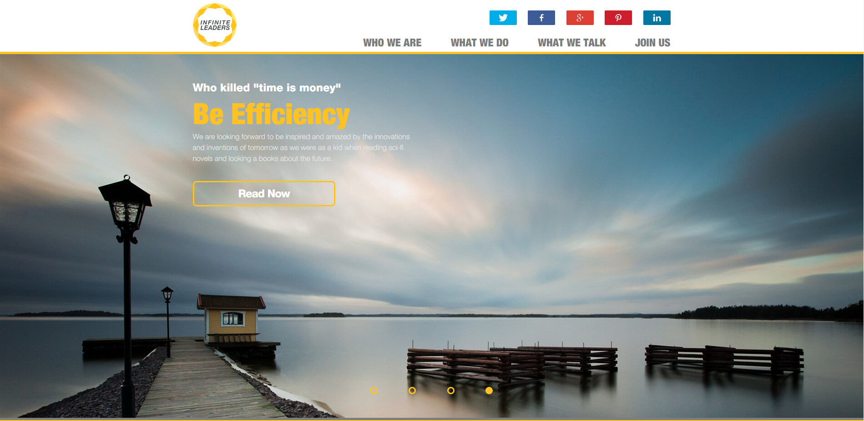

## Form Validation

## This one is a common function utilized by website to assist users input the valid information. And the system also can get the right information. So, it is a good way to improve user experience.

## One of the interesting things is that the input tag has a “required” attribute in HTML5, which calls the browser to help to check that this field has been filled in. That means that we don’t need to write a specific function to make users fill in all required fields.

In this JavaScript program, if the information filled by the user is invalid. It will arouse an error icon at the end of this input to tell users your input is invalid. On the contrary, a right icon will be displayed.

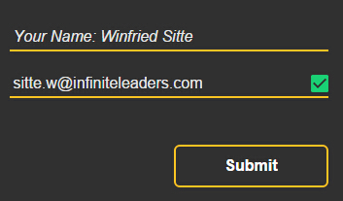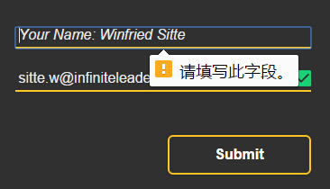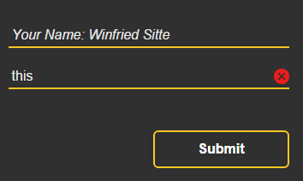

# Pop-up Register Form

According to our design document, we think the pop-up register form is acceptable. Because jumping to another page to fill in a form is not convenient for users. It increases the number of operation steps. In our implementation, after clicking “Register” button at the end of each “project-detail” pages, a gentle and fluent animation will be provided for users to display register form. Thus, this function decreases unnecessary page-jumping and offers a good interaction.

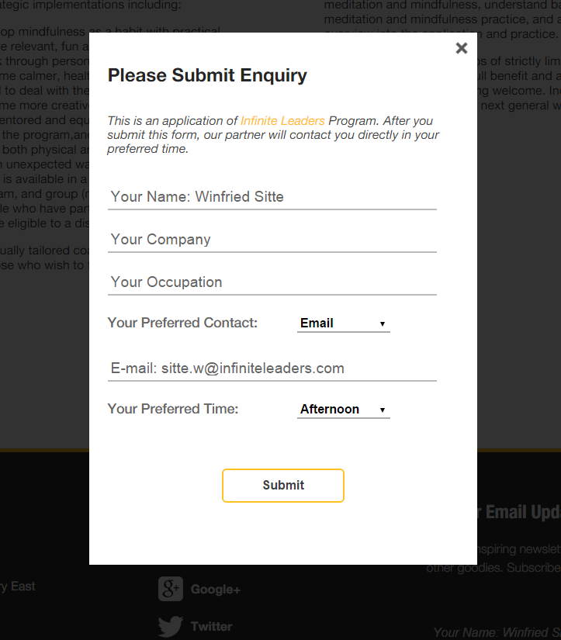

# Back-to-Top

This is a pretty small program, which just has three lines code. But, it is a useful function for visitors. In content pages, some articles are really long and make their pages are long, too. When people browse this kind of pages, if they read all the contents, they have to scroll up a lot to return to the top of the page. In order to solve this problem, we set up a small fixed yellow button in the bottom-right, people can click here to return to the top of the page quickly. Therefore, it is a small but fancy functionality.

